HEALTH CARE

How a 3-star general came to believe in psychedelic medicine
Independent experts gave a psychedelic treatment for PTSD a scathing review. Some in Congress want it approved anyway.
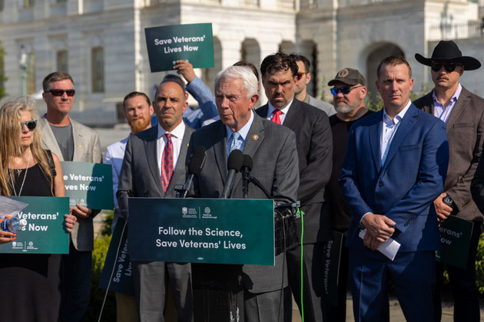
Rep. Jack Bergman (R-Mich.) is part of a push by lawmakers with military ties to persuade the FDA to approve psychedelic therapy. | Healing Breakthrough
By ERIN SCHUMAKER
08/05/2024 05:00 AM EDT
Updated: 08/06/2024 01:21 PM EDT

A 77-year-old retired Marine Corps general has emerged as an unlikely advocate for treating veterans suffering from post-traumatic stress disorder with the psychedelic drug ecstasy.
Jack Bergman flew helicopters in Vietnam, earned three stars, and is now in his fourth term representing a northern Michigan district in the House. A Republican, he sees promise in psychedelics that a group of mostly psychiatry professors who advise the FDA didn’t when they recommended the nation’s drug regulator turn down a pharmaceutical company’s application to offer MDMA along with therapy as a PTSD treatment.
Bergman is now part of a push by several other lawmakers with military ties, the mogul Elon Musk, doctors, investors and advocates of drug legalization, to persuade the FDA to overrule its advisers. The agency plans to make a decision this week.
“Every day that goes by that research isn’t being done, that’s more lives being lost, primarily to suicide,” said Bergman. “A lot of those veterans are on a dark path.” Bergman then pulled his fingers into the shape of a gun, aiming them at his head.
“Every day that goes by that research isn’t being done, that’s more lives being lost, primarily to suicide. A lot of those veterans are on a dark path.”
Rep. Jack Bergman
An FDA rejection of Lykos Therapeutics’ MDMA and talk therapy application would likely curtail the burgeoning psychedelic revolution — drug companies are studying several others as potential mental health treatments — while a green light would propel more research. But given the advisers’ opposition, the advocacy from lawmakers and their outside allies will also raise questions among many doctors about whether the agency bowed to a pressure campaign.
Lykos says it’s taking steps to assuage the advisers’ concerns.
This week, the company announced it was establishing an independent advisory board of experts in corporate and medical ethics, innovation, psychiatry, and military and veteran health, to help oversee their potential commercial launch.
It’s not uncommon for the FDA to reject a new drug application, but it overrules its advisers about only a third of the time.
Motivated by the suffering he sees among veterans with PTSD, Bergman said he and his allies are “gently but positively” leaning on the FDA to approve Lykos’ application. On Monday, a bipartisan group of 80 representatives and senators, led by Bergman, sent letters to President Joe Biden and FDA Commissioner Robert Califf, arguing that the FDA should fast-track approval for the treatment.
“The strategy here is to put pressure in a positive way so that the bureaucracy feels it’s OK to assume some risk,” Bergman said.
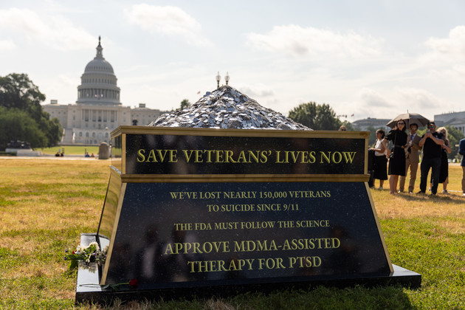
In July, veteran advocates installed a tombstone near the Capitol. They covered it in dog tags to represent veterans who'd died by suicide. | Healing Breakthrough
At a recent Capitol Hill press conference, Bergman stood with the other founder of the Congressional Psychedelics Advancing Therapies Caucus, Rep. Lou Correa (D-Calif.), as well as Reps. Jimmy Panetta (D-Calif.), a former Navy intelligence officer whose father, Leon, once led the Defense Department, and Morgan Luttrell (R-Texas), a retired Navy SEAL who has taken different psychedelic drugs to treat trauma he experienced from a training accident. Not far away, a tombstone prop was piled with dog tags representing veterans who’d taken their own lives. The inscription urged the FDA to “follow the science.”

MOST READ

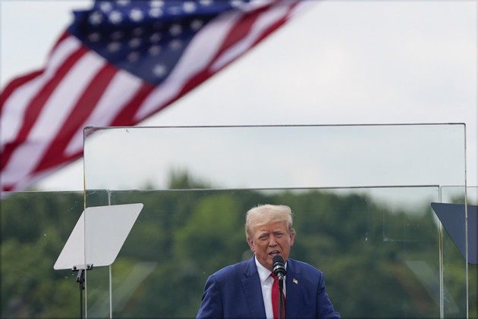

- Harris upended Trump’s electoral fortunes. Just look at North Carolina.
- The steel plant that saved Vance’s family from poverty is getting $500M from Biden. One worker says that ‘doesn’t really change anything’
- ‘It’s not a pro-life position’: Anger after Trump says no to Comstock
- Trump attacks Walz over DNC speech and tries to distance himself from Project 2025
- We Dug Into the 2024 Polling Crosstabs. What We Found Was Stunning.
The lawmakers pointed to Lykos’ case, that most of the people with PTSD who took MDMA and received the company’s therapy no longer met the diagnostic criteria for the disorder.
The FDA’s advisers saw it differently. They found the treatment ineffective, and its risks greater than its benefits. They called out Lykos for missing safety data, therapist misconduct and a culture of psychedelic evangelism.
The lawmakers backing Lykos have a lot riding on approval. Bergman and Correa were among those who led efforts in Congress last year to get provisions in funding bills for the VA and the Defense Department promoting psychedelics and they’ve repeatedly told veterans who’ve tried everything else that psychedelics could help them.

A search for new treatments
Long derided as counterculture party drugs, psychedelics are getting another look because of the widespread belief they have potential to treat mental illnesses that afflict more than a quarter of Americans, as well as dissatisfaction with existing treatments.
In 2021, there were 14.5 million adults who had at least one major depressive episode and 13 million people with PTSD, according to federal data. Veterans are disproportionately affected.
Traditional PTSD treatments like selective serotonin reuptake inhibitors, such as Zoloft and Paxil, which cause the brain to release the mood-altering chemical serotonin, are often ineffective and weaning off them can cause unpleasant side effects.
The psychedelics already in use include ibogaine, derived from an African shrub, 5-MeO-DMT, which comes from the Colorado River toad, and psilocybin, also known as magic mushrooms.
Correa traveled earlier this year to a clinic in Tijuana, Mexico, where American veterans have gone for psychedelic treatment. He said that no matter what the FDA decides about MDMA, people are going to use psychedelics to treat their mental illnesses.
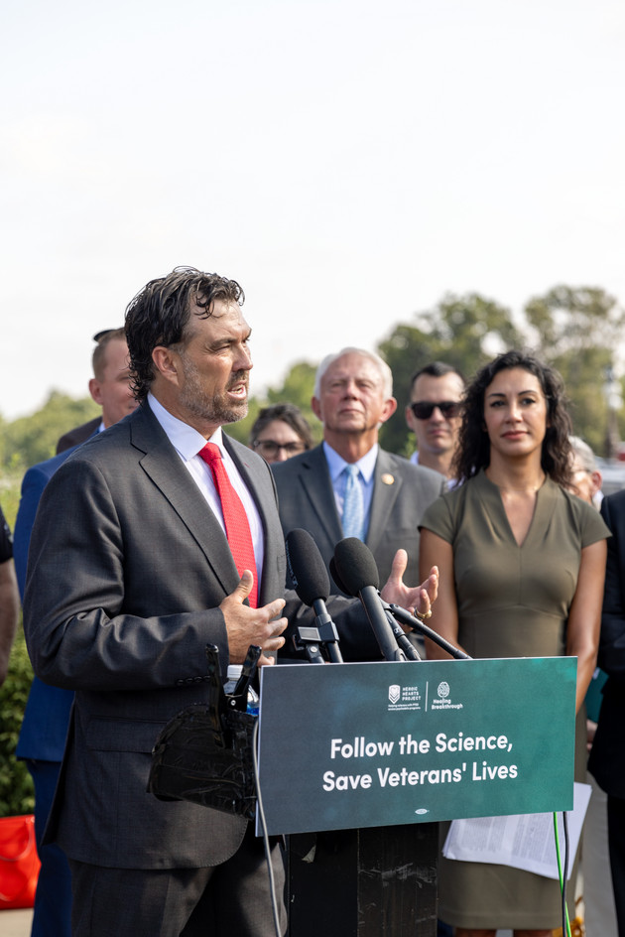
Rep. Morgan Luttrell (R-Texas), a retired Navy SEAL, has traveled to Mexico to receive psychedelic therapy not available in the U.S. | Healing Breakthrough
Luttrell credits ibogaine and 5-MeO-DMT with helping him overcome trauma after his Black Hawk helicopter went down during a training mission.
The bipartisan group in Congress is doing its best to “keep the spotlight very hot on our desire for this to move through now,” Luttrell said.
But it’s a delicate balance. At one point, Luttrell asked colleagues in the Congressional Psychedelics Advancing Therapies Caucus whether to meet with Califf, but the lawmakers decided the optics of such a direct approach weren’t good. Instead, the group hopes the FDA overhears the parallel conversations they’re having.
“We didn’t want to poke the FDA right in the nose, because that creates aversion and they’re going to keep their head down,” Bergman said.
The FDA declined to comment, since Lykos’ application is currently under review. It pointed POLITICO to draft guidance it issued on psychedelics clinical trials last year as the agency’s current thinking on the issue.
One ally isn’t as diplomatic. Rep. Dan Crenshaw, who like Luttrell is a Texas Republican and a former Navy SEAL, skewered the FDA advisers on X, accusing them in a video of doing the bidding of pharma companies whose products would suffer if Lykos’ application were approved, and of bias against service members.
Musk reposted the video for his 193 million followers with the endorsement: “Dan’s right about this.”
In an interview, Crenshaw, who lost an eye in Afghanistan, said psychedelics have saved some of his best friends’ lives and that it was reasonable for Lykos’ therapists to express passion for a treatment that works.
“Nobody is putting … their whole heart and soul into a therapy or drug or device and they don’t like it,” he said.

The risk of overcaution
But to approve Lykos’ regimen, the FDA will have to override a decisive “no” recommendation from its advisers.
They voted 9-2 that Lykos’ regimen is not effective and 10-1 that the therapy’s risks outweigh its benefits. In addition to safety and misconduct concerns, the experts said the company’s studies were tarnished because they were functionally unblinded. Participants figured out who received the drug and who received a placebo.
“We were disappointed in that outcome, but not necessarily surprised by the questions that they raised,” Amy Emerson, Lykos’ CEO, told POLITICO.
“We’re advancing a really novel treatment,” she said, adding that the advisory committee is “important for raising hard questions.”
Emerson, who’s met with Bergman to discuss the situation, is still hopeful that Lykos’ MDMA therapy will be available next year. “We’ve worked closely with the FDA for years to address this and work on a program that would generate the data that was appropriate to review. They’re very familiar with our protocols.”
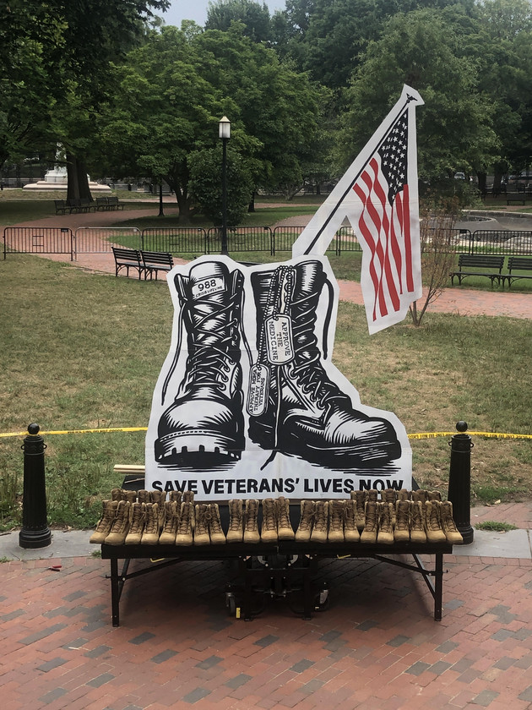
Veteran advocacy groups installed an art installation meant to get the FDA's attention in Lafayette Square in front of the White House in July. | Heroic Hearts Project
But prior to the advisory panel meeting, the zeal of Lykos’ therapists was a red flag for the Institute for Clinical and Economic Review, a Boston nonprofit that evaluates new drug applications. It gave Lykos a scathing critique this spring.
The institute report said the psychedelics community was “like a religious movement” and that Lykos researchers sought to inculcate that passion in patients.
Despite the poor reviews of Lykos’ regimen, other psychedelics specialists say they still see good cause for the FDA to approve it.
Rachel Yehuda, director of the Center for Psychedelic Psychotherapy and Trauma Research at Icahn School of Medicine at Mount Sinai in New York City, said FDA approval would make it easier to continue studying MDMA-assisted therapy for veterans. She recently wrapped up such a study with veterans in the Bronx.
While it’s important to understand and investigate the concerns detailed by the advisory committee, she said, “it’s also important not to get hijacked by them.”
In Lykos’ 2023 trial, 71 percent of participants who received the combination of MDMA with therapy no longer met the criteria for PTSD, the company said.
Yehuda, who has worked with Lykos over the years, sees those strong results as a milestone given the long, unfruitful search for effective PTSD treatments.
The FDA is a conservative regulatory body, she noted, designed to protect people from food and drugs that might be harmful.
But it’s possible to be too cautious, she said, given the magnitude of the country’s mental health problems. “At what point do you do surveillance of something post-approval rather than prevent something from seeing the light of day?”

